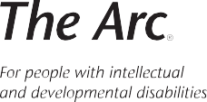
Beneficiary Support Toolkit for Trust Professionals

Chapter 1 Resource

Respectful Communication Tips

Some people are nervous about or unsure how to communicate with people with disabilities, particularly people with intellectual and developmental disabilities (IDD).

Below, we provide tips and resources on communicating with and about people with disabilities, including disability etiquette, disability competence, and communicating with people who use augmentative and alternative communication (AAC).

Practice good disability etiquette:

- Speak directly to the person with the disability, not to their interpreters, caregivers, or other companions.

- Treat every person, including people with disabilities, with dignity. Treat and talk to adults with disabilities as you would any other adult in a similar situation.

- Appreciate what the person can do, rather than focusing on what they can’t do.

- Do not call people without a disability "normal."

- If someone with a disability appears to need help, introduce yourself and ask to help in a matter-of-fact manner, e.g., "Hi, my name is _____. May I help in any way?" Don't insist on helping. Helping before it is requested is considered rude and can sometimes be dangerous.

- If a person with a disability asks for assistance, listen to and follow any directions that the person may give on how you can help them. If you don’t know how to help, ask what you can do.

- If a person's speech is hard to understand, be patient and respectful as communication may take longer. Do not interrupt or finish the person's sentence. Do not pretend to understand. Clarify what is being communicated. It is okay to ask several times what the person is saying. If you don’t understand after a few tries, ask if there are alternative methods you can use to communicate. The most important thing is to make sure you understand what is being communicated. For example, you can say "What you are saying to me is important, but I did not understand everything you said. Could you please tell me again?” Or, you can restate what you heard, and ask if your understanding is correct.

- It may take extra time for a person to say things or get things done. Let the person set the pace.

- Explore your mutual interests in a friendly way. Don't forget to laugh together.

Remember: People with disabilities are just people. They will have both good days and bad days. Just like your interactions with all people are different based on your day, their day, and your relationship with them, your interactions with people with disabilities will be different depending on each person and circumstance.

Use disability-competent language:

The disability community commonly uses person-first language when talking to, with, and about people with disabilities. Person-first language reinforces the fact that a person is a person foremost and the disability that he or she experiences comes afterwards. Examples of person-first language are included in the chart below.

Communicating With and About People With Disabilities
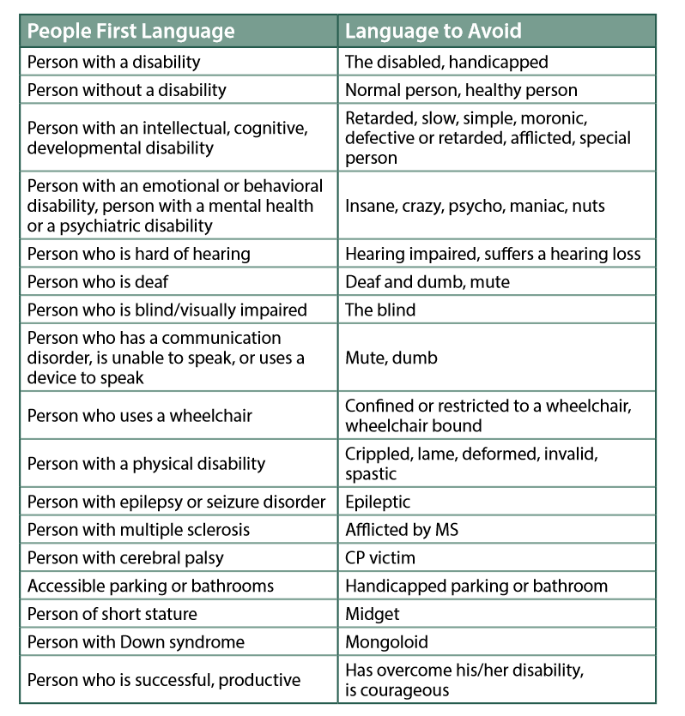

However, some people with disabilities prefer to use identity-based language to refer to themselves (e.g., autistic, blind, or Deaf). They may choose to use this language because they believe that disability is a part of who they are, because they are proud to be who they are, and/or because they want to take ownership of how they refer to themselves.

When talking with people with disabilities, begin by using person-first language. As you talk with the person, listen to how they refer to themselves, and mirror (with one exception, noted below) the terms that the person uses.

NOTE: Never use the term “retarded”, even if a person or their family uses the term. Though the term “mental retardation” may still be used in the medical field and referenced in some laws, the words “retarded” and “retardation” are derogatory and demeaning.

Review the terms you use for beneficiaries:

We use the term “beneficiaries” to describe the people served by the trust. However, people may use a variety of other terms (e.g., client, customer, member). The terms people use to refer to people with IDD they serve – and the way people feel about the term, - may become out-of-date, or as mentioned above, be unempowering or derogatory.

Trusts should consider reviewing the terms that use for their beneficiaries periodically to ensure that the term used makes sense to the people being served and is empowering and supportive. This review should include asking beneficiaries about the term used – and whether a different term should be considered.

Practice good AAC etiquette:

Beyond the words we speak, we all use AAC every day to communicate. AAC includes our gestures, body language, and facial expressions. It can also include tools we use to communicate with each other, like pencil and paper, boards with pictures, words, or letters, pictures or words on a computer screen, or even speech-generating devices. Check out this quick video on AAC to learn more about this type of communication.

According to the American Speech-Language-Hearing Association, over 2 million people use augmentative and alternative communication (AAC) to help them communicate at school, work, and with family and friends. Some people may use just AAC to communicate, while other may speak short words or phrases aloud but use AAC to communicate more complex thoughts.

Many people are unsure how to communicate with people who use AAC. Here are some AAC etiquette rules that you can use to successfully communicate with people who use AAC.

- Ask how a beneficiary wants to communicate and respect their wishes. People’s preferences may change based on the situation or on their needs that day. This video from two AAC users describes how and why needs may vary and how you can respectfully engage with AAC users.
- If the person is a new beneficiary, ask whether they use any AAC devices. Learn more about how the person uses AAC ahead of any meetings.
- Be patient and flexible. Technology does not always work as planned. Communicating using AAC may also take longer than anticipated.
- Communicate with the person, not the AAC device. Use your typical eye contact, body language, and speech with the person.

- Assume competence and understanding. Don’t limit topics of discussion or make assumptions about what a person can understand because they use AAC.
- Check whether you understand what a person is communicating. AAC does not always portray the full meaning of what someone wants to communicate. It may not be able to account for tone or emotion. When you don’t understand what is being said, recap what you do know and ask for more explanation.
- Ask one question at a time so that people can respond to each question in turn. Make sure a person is done speaking before moving to a next topic or walking away.
- Respect an AAC user’s privacy and space. Don’t look at a screen unless you are invited to look, and don’t touch a device without asking.

Share With Us
Did any of these tips and resources spark a memory or story you want to share, or a resource or tool you need? Complete this form to contact us and share your ideas!

Date Revised: August 4, 2021.

Adapted with permission from Alliance of Information and Referral Systems (AIRS). 2019 AIRS I&R Training Manual. Vol. 1: Training Community Resource Specialists, p. 401-402.
Centers for Disease Control and Prevention. “Communicating With and About People with Disabilities.” Disability and Health, 2018, www.cdc.gov/ncbddd/disabilityandhealth/pdf/disabilityposter_photos.pdf.
These recommendations are based on etiquette rules mentioned in “AAC Etiquette Essentials: Chatting with Someone Using Tech to Talk,” by Montech at the University of Montana.

