HealthMeet Blog: April 18, 2014

HealthMeet: Top 5 exercises for people with intellectual and developmental disabilities
By Jared Ciner, Certified Personal Trainer, Disabilities Support Counselor
& Founder/Director of SPIRIT Fit & Health

As you may already know, an extremely high percentage of people in America are suffering from obesity. What you may not know is that people with developmental and other disabilities are 58% more likely to be obese than the general population, and they make up roughly 20% of our country’s citizens. As a society, it is our duty to provide the necessary resources and support that enable people with disabilities to be healthy. The purpose of this article is to begin enabling people with intellectual and developmental disabilities to take control of their lives through the practice of health-promoting exercises that are safe, effective and tailored specifically towards their needs.

As a certified personal trainer, I believe that partaking in proper exercise and physical activities empowers us as human beings, and allows us to reach our mental, emotional and physical potential. As a support counselor, I know that people with I/DD often require adapted strategies in order to accomplish certain functional goals. In April of 2013, I teamed up with Sam Smith, certified personal trainer and proud young man with Asperger’s syndrome, to design and implement group health & fitness programs for teens and adults with intellectual and developmental disabilities. Below are five exercises that we encourage all people, including those with an I/DD, to practice in order to maximize their strength, health and independence. Each exercise focuses in improving stability, strength and cardiovascular endurance.

#1 PLANK

Instructions | Place both hands on the ground directly underneath your shoulders. Then extend your legs behind you and hold your midsection up with your back straight. Hold this position for as long as possible. If you can hold for 1 minute or longer, try the advanced version!
Value | 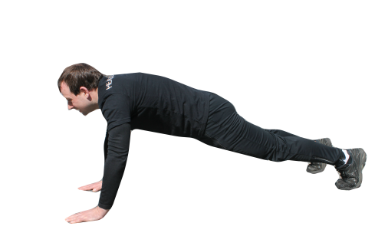  The plank is one of the safest and most effective ways to strengthen your core. There is little to no spinal motion which helps protect your back. This also allows you to practice proper push-up position, eventually enabling you to do push-ups! It is a relatively simple exercise and it works large muscle groups which is the best way to reduce your body fat percentage.
Moderated | Put your hands on a secure, elevated surface such as the edge of your bed.
Advanced | Lower your body onto your elbows rather than your hands. Keep your back straight!

#2 HIGH KNEES

Instructions | 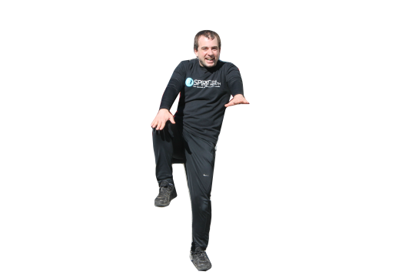  Stand up tall with your back straight. Place your hands in front of your torso and lift one knee up to your hand. Alternate legs and try to bring your knees as high as they can go. Do this exercise for 30 to 60 seconds. Only try advanced version if you have healthy joints.
Value | This exercise provides a stretch in your hips, legs and back, and it will help strengthen  your core. It also improves balance and provides excellent cardiovascular training  which will improve your stamina, endurance and weight management.
Moderated | Do this exercise in a seated position.
Advanced | Increase your tempo and hop up from one foot to the next as if you are running in place.

#3 ARM CIRCLES

Instructions | Stand up tall and extend your arms out to the sides as far as they can go. Bring your shoulder-blades back towards each other, and move your arms forward in small circles for 20 to 30 seconds. Then move your arms backwards for 20 to 30 seconds.
Value | 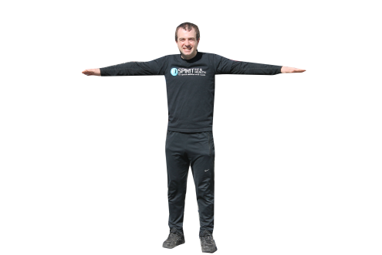  This exercise will strengthen the muscles in your shoulders, neck and upper back. This will increase your upper-body strength and help improve your posture.
Moderated | Rather than circles, raise your arms above your head, then back to your sides.
Advanced | Combine this exercise with exercise #2 High Knees (excellent for coordination)

#4 SINGLE-LEG BALANCE

Instructions | 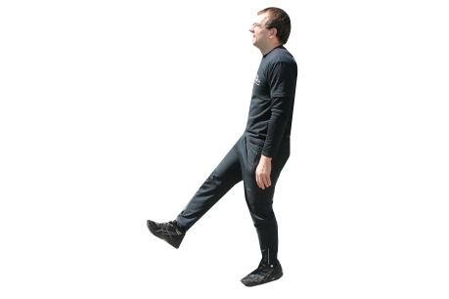  Stand up straight, take a deep breath and find a good center of balance. Then lift one foot off the ground. Try to balance for 30 seconds, then switch feet. If you can do both sides without tapping your elevated foot to the ground, try the advanced version.
Value | Balance is a tremendously important life skill for all people, particularly those with I/DD.  This exercise will help keep you stable and reduce your risk of injury due to falling.
Moderated | Practice this holding onto a stable object such as a chair. Do your best to lift your hands  as much as possible, but keep them close to your supporting object for safety.
Advanced | Try this exercise with your eyes closed!

#5 SQUATS

Instructions | Stand up tall with your feet shoulder-width apart. Sit your butt backwards and bend your knees as if you are sitting into a chair. Keep your knees behind your toes (a helpful tip here is to try to keep your weight on your heels rather than your toes), and try to keep your back parallel to your shins. Doing this in front of a mirror or partner will help. Squat until your legs reach a 90 degree angle or until you cannot hold the proper form described above. Repeat 10 to 20 times.
Value | 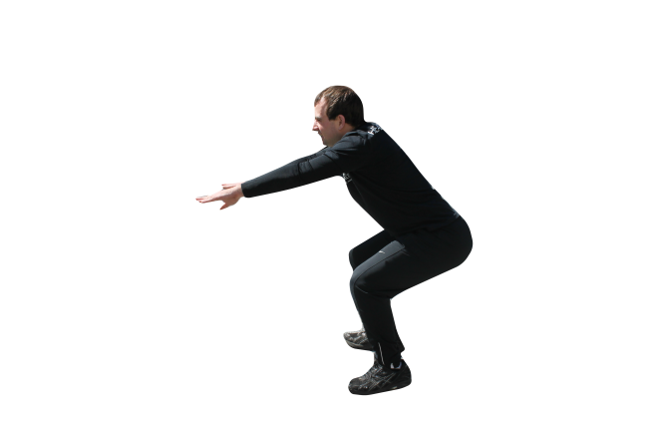  This exercise stretches and strengthens your core, hips and legs. It also enables you to practice a movement that is performed multiple times every single day (sitting in a chair, getting into a car, tying your shoe etc.). It ensures that the muscles involved in this motion are capable of supporting your body in a way that will keep your knees and back protected and safe.
Moderated | Chair Squat – Tap your butt down to a chair, then stand back up
Advanced | Squat Jump – Squat down to a 90 degree angle and then jump as you  come up. Try to immediately go back into a squat as you land. Then repeat.

*Instructions describe one set of each exercise; 2-3 sets are recommended per practice.
*Special thanks to Sam Smith Fitness Model & SPIRIT Fit & Health Instructor

